Quality Assurance Guidelines

Internal & External Moderation
of Workability Programme

The following quality assurance guidelines should be used in the context of the Workability programme structure.

The quality assurance process aims to ensure the standards set by the awarding body are being maintained. It is highly dependent upon the way that assessment is conducted and reviewed. It is essential that both trainers (assessors) and a named internal moderator fully understand and implement the entire quality assurance system.

In each organisation/site, quality assurance takes place at three levels as detailed on the table below:

Process | Personnel | Purpose
Assessment | Trainer/s  in organisation | - To make an objective judgement, based on set assessment criteria, of how a student performs an assessment task.  - To record this assessment judgement.  - To keep assessment records for the purpose of moderation.
Internal Moderation | Internal Moderator  in organisation | - To ensure that assessment is done in a standardised way by all assessors in a particular site/organisation and in accordance with awarding body criteria.  - To internally approve all assessment decisions in advance of external moderation.  - To ensure that necessary documentation relating to assessment is fully completed and available for inspection by External Moderator.
External Moderation | Subject Moderator/ Quality Reviewer  External to organisation | - To review both the assessment process and the internal moderation process.  - To verify assessment decisions and thereby verify the award of credit.  Subject Moderation will take place at a Group Moderation Meeting

Both assessment and internal moderation must happen within every organisation and at every site on which the workability programme is being run. Therefore each organisation must have assessors (trainers) to assess students’ performance and must nominate one (or more) staff member(s) to be responsible for internal moderation. Although the internal moderator can be an assessor/trainer, he or she may not internally moderate his/her own work.

A subject moderator/external quality reviewer will be appointed by the awarding body upon registration of the programme. He/she will externally moderate the programme (ie, review the work of the internal moderator and in some cases sample students’ work again).

Documentation

A number of documents (for use by the trainer/s and the internal moderator) have been prepared to specifically relate to the Workability programme in line with OCN (NI) requirements.

Quality Assurance Forms to be used by trainers (2)

- Class Tracker – The Class Tracker Form should be used to record which units have been completed by each student and the date on which they have been completed.

Purpose: By looking at this form, it is easy to see when each student has completed each unit as Learning Outcomes (LO) have been grouped accordingly. It should be kept in the trainers’ folder and gives an ‘at a glance’ record of where each student is at in the programme.

 | Unit 1 | Unit 2 |  |  | Unit 3 |  |  |  |  | Unit 4
LO | 1.1 | 2.1 | 2.2 | 2.3 | 3.1 | 3.2 | 3.3 | 3.4 | 3.5 | 4.1
Completed (date) | 

- Remember that a student needs to complete all Learning Outcomes within each unit to be able to be put forward for accreditation for that unit (in the example above the student can be put forward for credit for unit 1, but not unit 2 as they still have LO 2.3 to complete).

When to complete: After each Learning Outcome (LO) has been achieved.

- Student Feedback Form – A Student Feedback Form should be kept in a section of each student’s individual file. It is used to record feedback given by students to trainers and by trainers to students.

Purpose: In keeping with the OCN NI ethos of learner involvement and encouragement, it is essential that students be given regular feedback on their progress. These forms will be viewed at moderation. They should be stored in each student’s folder.

When to complete: These should be used throughout the course, preferably after each training session. Trainers should write comments on progress and achievement, as well as improvements to be made. They should elicit feedback from the student on his/her views about self-performance and specific likes or dislikes in terms of content or the way elements of content were delivered by trainer.

Unit Title | Learning  Outcome / Assessment  No. | Comments from Trainer | Comments from Student (filled in by trainer if necessary) | Action | Student/Trainer Signature | Date
e.g Work, Jobs and skills | 1.1  Know what employment means | Brian had difficulty thinking of different skills/qualities associated with 2 jobs. This may be due to his lack of work experience | Brian has indicated that he would really like to go to a supermarket to see what sort of work people do there. | Select a number of jobs that Brian is aware of and discuss what type of people do these jobs. A visit to a supermarket is being arranged for 13/4/05. |  | 3/3/05

Internal Moderation

Each organisation/site must appoint a named internal moderator who will undertake moderation duties for the duration of the programme.

A trainer cannot act as an internal moderator for their own work (since it would be impossible to be completely impartial about their own assessment decisions).

However, if two trainers are delivering the programme in an organisation, they could feasibly moderate each others’ work.

Trainer A
Trainer B
Trainers A’s students’
evidence

Trainers B’s students’
evidence

Who is involved in Internal Moderation?

Both trainers and internal moderators should be present while documents are being reviewed for internal moderation.

Forms to be used by Internal Moderators

- Sampling Matrix

The Sampling Matrix Form is designed to be used by Internal Moderators to record all evidence which has been sampled during the moderation meeting. The Sampling Matrix Form needs to be completed by the Internal Moderator for each trainer delivering the Workability Programme. If two trainers are delivering the programme jointly to the same group of students, then only one form should be completed.

Purpose: It is not expected that the Internal Moderator will look at all the assessment evidence produced by the students (as the trainer has already checked this). However, by choosing a sample of evidence to look at, the Internal Moderator can identify any issues with the assessment decisions that have been made by trainers and/or any deficiencies in how the forms/evidence has been collected.

When to complete: In preparation for Internal Moderation

To complete the form, each group of students should be listed under the Student Name section. Their corresponding OCN NI Reg. No’s (found on the NOCN Learner Listing Document) should be listed in the Student OCN Number Section.
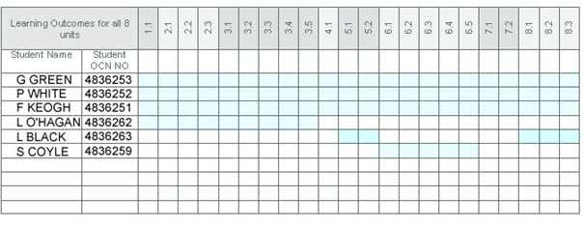

It also is a good idea to lightly shade/highlight what students are registered for which units, as not all students will complete 8 Units. For example G. Green is registered for all 8 units, whereas L. Black is registered for units 5 and 8 etc.

This shading will allow the Internal Moderator to select which evidence to sample for each student.

Please note that students must complete all Learning Outcomes for a unit (corresponding assessment sheets) to be able to be accredited for that unit i.e. unit 1 (1.1), Unit 2 (2.2, 2.2, 2.3) etc.

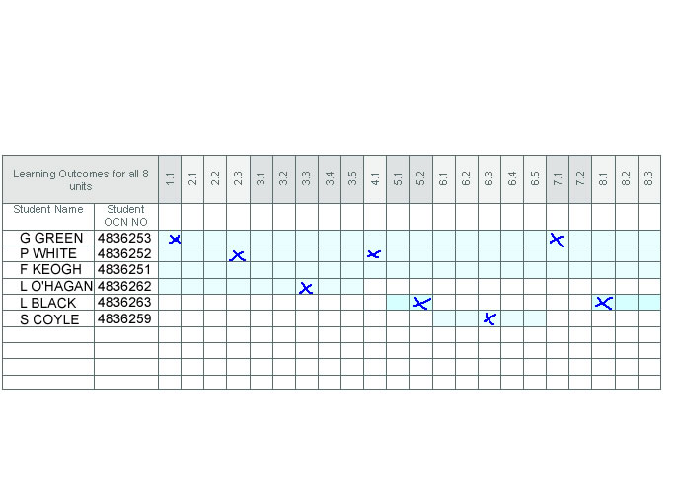
Internal Moderators should select a random sample of evidence to look at. Internal Moderators should aim to look at evidence from all students during the course duration.

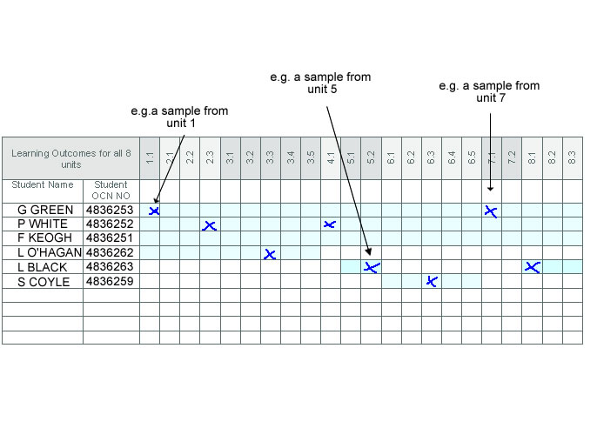
Internal Moderators should also aim to sample evidence from each unit that is being delivered. This may mean that some students are sampled more than once.

When should Internal Moderation occur?

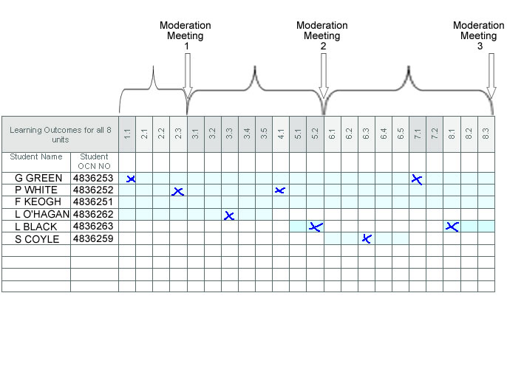
Internal Moderation should occur a number of times over each run of the course. For example an internal moderator may wish to hold moderation at regular intervals after an amount of work has been completed e.g.:

When claiming accreditation, the Sampling Matrix must be completed and returned along with your RAC (Recommendation for the Award of Credit) form to OCN before credit can be claimed.

- Internal Moderator Report
At each Internal Moderation, the Internal Moderator will complete a summary Internal Moderator Report.

Purpose: This report is used to record the Moderation meeting and will involve feedback to the trainer regarding the assessments that they have undertaken and the way that evidence has been collected and maintained.
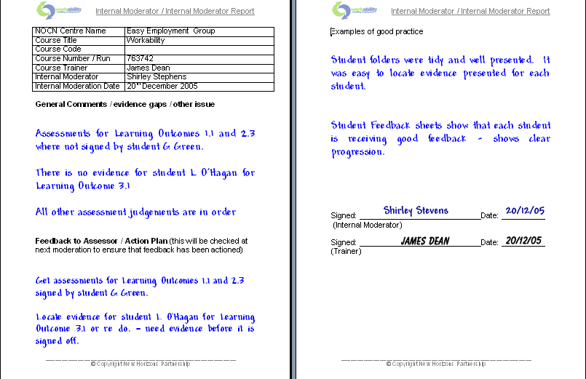

It is essential that trainers respond to any issues that the Internal Moderator requests i.e. trainer needs to repeat a certain assessment / feedback sheet etc.

The Internal Moderator should check that these issues have been addressed at the next Internal Moderation meeting.

Internal Moderators should give a copy of the Internal Moderator Report’s to the Trainer. Reports should be retained by the Internal Moderator for external review.

When to Complete: After the moderation meeting.

Quality Assurance Checklist

When you are an OCN NI approved Centre:

Trainers
- Register Students with OCN NI
- Supply Internal Moderator with Student Details
- Agree dates for Internal Moderation with Internal Moderator
- Begin to deliver Workability programme
- Assess Students on ongoing basis (using Workability assessment sheets provided)
- Provide Student Feedback using Student Feedback Form
- Complete Class Tracker Form (ongoing as Learning Outcomes are achieved)
- Collate all assessment evidence, Student Feedback Sheets and Class Record Form
- Prepare folders for Internal Moderation
- Attend Moderation

Internal Moderator
Pre-Internal Moderation
- Enter all students registered into the Sampling Matrix
- Agree Internal Moderation dates with Trainer
At Internal Moderation
- Use the Sampling Matrix, choose a random sample of evidence to inspect (using selection guidelines above)
- Check that all assessment tasks have been completed correctly and satisfactorily
- Check that all assessment sheets have been signed and dated by student and trainer
- Check that student feedback sheets have been completed regularly and signed by student and trainer
- Countersign and date everything that you inspect
- Complete Internal Moderation Form (retain copy and provide trainer with copy and verbal feedback
- If Internal Moderation has occurred previously, check that all requested action has been undertaken.
- Sign Recommendation of Credit (RAC) Form only when you are satisfied with all assessment decisions. *You must be able to stand over all evidence/assessment produced when you sign this form.
- Attend Subject Moderation upon request of OCN NI

