Internal moderation guidelines

Organisations who wish to run the New Horizons Independent Travel Training (ITT) Programme as an accredited programme need to select someone to be an internal moderator.
- An internal moderator is someone working within the organisation that will assess the trainers’ work and ensure the quality of the training is maintained.
- The organisation running the programme will decide who is a suitable moderator and this will be agreed before the training begins.

Note: The internal moderator does NOT have to have participated on the ITT training for trainers programme-their role is an administrative one. Please see the definition of an internal moderator taken from OCN Website:
“The internal moderation process is a very important aspect of moderation. The Internal Moderator’s role is to ensure that students are being assessed consistently across all aspects of the programme”

Note: the moderator is there to check the work of the trainer. The moderator does not personally assess students

What is a moderator required to look at?
- Student Workbook should be in full colour
- All Assessment Sheets should have ‘competency 4 – can do independently’ achieved, before progression to the next activity occurred and before accreditation was claimed.
- All assessment sheets have been transferred to a master matrix correctly for easy access
- Student Evaluation sheets have been completed
- All forms have been signed and dated by the appropriate trainer and student.

The Independent Travel Training Programme is comprised of 12 activities, all apart from activity 4, are assessed.

The programme has both a Theory and Practical element. The theory is delivered in a classroom setting using the Student Workbook, Animations and Sounds. The practical session is undertaken after the theory session (same day or shortly afterwards) and the trainers assess students using practical assessment sheets

- The theory element of the programme (Student Workbook) is never assessed. It is merely used to convey concepts to the students. It therefore cannot be used as evidence of fulfilling the learning outcomes. Internal Moderators should check that the student workbook is in full colour (if it is being used).

- The practical assessment is competency based and is assessed. Due to this, the practical Assessment Sheets are directly related to the Learning Outcomes. The Learning Outcomes can be found at www.newhorizonspartnership.co.uk/ittunits.pdf

- It is important to note that students must achieve complete independence (competency 4) before they can move on to the next activity.

Example A: Practical Assessment Sheet for Activity 1 below shows that this student can progress to Activity 2 as Competency 4 has been achieved in every section.
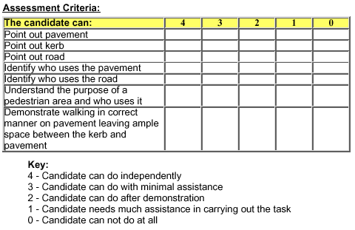









If this student had not achieved 4 as in the example below, they could NOT have progressed to Activity 2 at this time, but would repeat the assessment as many times as necessary to achieve competency 4.
“Example B”









Consequently, Student in example ‘A’ might have 1 Practical Assessment Sheet for this activity, and Student in example ‘B’ might have numerous Practical Assessment Sheets.
The internal moderator should check that competency 4 has been reached before progression to the next activity.

Student Feedback Sheets
To ensure good practice, trainers have also been supplied with Student feedback sheets. The Student Feedback Sheet should be completed after every Theory and every Practical Session. They are specific to each student and may include both how a student feels that the session went, as well trainer comments on how that particular student progressed.

Each student’s file should include for each activity (preferably in this order):
- Student Workbook pages in colour
- Complete assessment Sheet
- Student Evaluation

The master matrix should be filled in as soon as the practical assessment has been carried out. It is advised to keep the master matrix separate from the assessment sheets so that 2 copies of work carried out are available.

Step by step guide

The internal moderator will use 3 forms to document their moderation visits:

Form 1 - Internal Moderation Sampling Matrix Plan D (see Fig.1.1)

What is the purpose of this form?
- This form is used by the internal moderator to plan when they will be meeting with the trainer to moderate a sample of work. This may change depending on how far students are able to progress through the programme.

When should it be completed?
- It should be completed as soon as the internal moderator has details of all students enrolled in the course. This is so they can plan which work to sample.

How is it completed?
- If possible, internal moderators should moderate/sample at least one activity in each of the three units by the end of the programme.
- If possible, internal moderators should aim to sample each student at least once during the programme. Each trainer should also be sampled at least once during the programme.

(See next page for example of a sampling matrix plan)

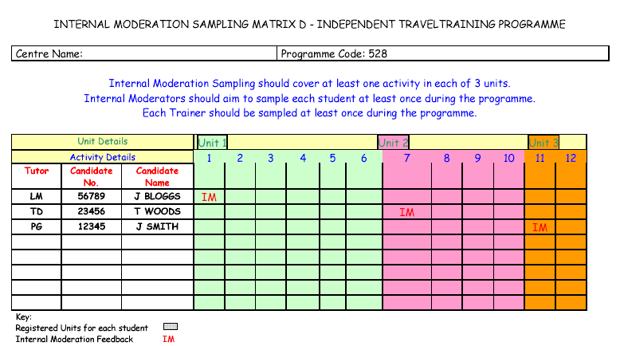
Fig.1.1

Looking at the example above, you can see that the internal moderator has chosen to assess the following:

The records for J Bloggs will be assessed on UNIT 1, ACTIVITY 1
The records for T Woods will be assessed on UNIT 2, ACIVITY 7
The records for J Smith will be assessed on UNIT 3, ACTIVITY 11

Form 2 - Internal Moderator report form “E” (see Fig 1.2)

What is the purpose this form?

This form is used to summarise the outcomes of the internal moderation meeting between moderator and trainer(s).

When should it be filled in?

The internal moderator report should be completed immediately after each internal moderator visit (Suggestion: The moderator should ideally moderate their chose sample of work at the end of each unit. This would mean a total of 3 moderation visits)

How is it completed?

When the internal moderator is checking the selected samples of work this sheet enables them to document their finding about the standard of work they looked at and recommend any improvements they may wish to suggest.

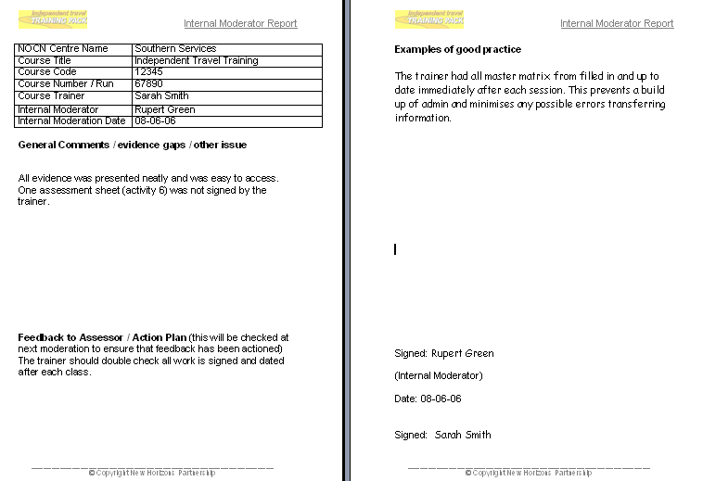
Fig 1.2

Form 3 - The recommendation for the award of credit form (RAC)
What is the purpose of this form?
- When the internal moderator is satisfied with the quality of the trainers work they will complete a recommendation for the award of credit form (RAC) which is sent to the Open College Network.
- In layman’s terms, this is the form which the internal moderator completes to tell the Open College Network that they have checked the trainers work and are satisfied with the standard.
- They will then recommend the award of credit to successful students via the RAC form.
When is it completed?
- The RAC form is completed when certification is being claimed for successful students. This is normally at the end of each unit or the end of the programme.
How is it completed?
- The RAC form is signed and dated by both the internal moderator and the trainers to confirm that they are both happy that the student has achieved the required standard for certification.
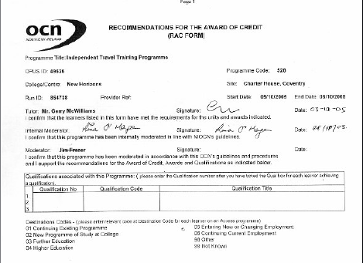


Internal moderation

Frequently Asked Questions (FAQ)

Where do I get these internal moderation forms from?

- The moderation matrix and report forms can be downloads from the following web link:
www.newhorizonspartnership/ittdownloads.hfml
If you do not have access to the internet please inform New Horizons and we will mail you these forms directly.

- The RAC form will automatically be sent out to your organisation by OCN when you register students on the programme.

What will the internal moderator look at?
He/she will check that
- All forms have been completed, signed and dated
- All OCN regulations are adhered to and material are stored in the correct place for the external moderator to access
- Feedback is given throughout to the end users
- Students did not move onto the next activity until full competency was reached in the preceding task
- Each Student’s folder is neat and tidy and easy to access.

Can an internal moderator be another Independent Travel Training Programme trainer from the same organisation?
It is ok for two trainers to moderate each other’s work as long as they are not jointly travel training the same group of students in travel skills. The moderator should be able to look at work with no bias.
Therefore they should not be moderating their own work.
How do we choose an internal moderator?
An internal moderator should not be directly involved in training the class whose work they are moderating as they need to look at the work independently and without bias.
Moderation does not involve a lot of time but it is important that it occurs regularly throughout the programme so the selected moderator must commit to this before the programme begins (1-2 hours every few months normally suffices).
Who checks the internal moderators work?
An external moderator/quality reviewer from the OCN will moderate the internal moderators work. When you contact your local OCN they will inform you of how this process works.

Please feel free to contact New Horizons directly if there are any further questions.

Internal Moderation: Step by Step
1. Sampling matrix plan

Complete before course begins
2. Internal Moderation report

Complete after moderation visit
3. Internal moderation feedback sheet
Complete after witnessing one training session during programme
4. RAC form
Complete when work has been checked and certification is required

